INSTRUCTIONAL OBJECTIVES: Pages 117 – 121 (Chapter 1: Inverse Relations and Inverse Functions).
- Review the definitions of relation and function.
- Understand the definition of a One-to-One Function.
- Be able to use the Vertical Line Test and the Horizontal Line Test to identify One to One Functions.
- Find the inverse of a function.
- Know when to use inverse functional notation.
- Know how to prove that 2 functions are inverses of each other by the appropriate use of composition.
- Technology: Smart Board, graphing calculator (TI-83 or TI-84).
TUESDAY, 9.3.24
Any questions about the previously assigned problems?
- Quick Review 1.5 on page 121 (#1 – 10).
- Exercises 1.5 on page 122 (# 9 – 12, 13, 15, 17, 19, 23, 27).
Class Work/Homework:
- Page 122 (#29, 31).
- On the coordinate plane on page 2, graph the following:
- f(x) = 2x + 1
- f ⁻¹ (x)
- g(x) = x
Make sure that you show their mutual point of intersection.
Show that f o f ⁻¹ = x.
Show that f ⁻¹o f = x.
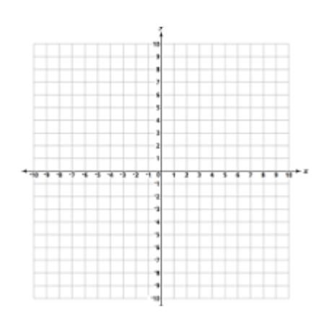

THURSDAY, 9.5.24
Discuss the previously assigned work.
Class Work/Homework:
Page 122 (#28, 30, 32).
Page 123 (#41, 43, 44).
FRIDAY, 9.6.24 A-DAY, NO CLASS.

